



**SM6P07NI Digital Media Project**

**20% Research and Proposal**

**2024-25 Autumn**

**Student Name: Kritan Chandra Shrestha**

**London Met ID: 22067395**

**College ID: NP01MM4A220078**

**External Supervisor: Saugat Basnet**

**Internal Supervisor: Parbat Bhujel**

**Assignment Due Date: 8th January, 2025**

**Assignment Submission Date: 8th January, 2025**

**Word Count: 2204**

*I confirm that I understand my coursework needs to be submitted online via Google Classroom under the relevant module page before the deadline in order for my assignment to be accepted and marked. I am fully aware that late submissions will be treated as non-submission and a marks of zero will be awarded.*

# Abstract

This project focuses on the design of a user-friendly and functional UI/UX interface for **AgriBaato**, a platform aimed at improving agricultural transactions in Nepal. The goal is to create a design that caters to the needs of both farmers and agribusinesses, offering features such as real-time market price updates, a bidding system, and a collaborative marketplace. The design emphasizes accessibility, simplicity, and inclusivity, ensuring that users with varying levels of digital literacy and access to technology can easily navigate the platform.

**Table of Contents**

Abstract 2

Table of Figures 1

Section A: Research 2

1. Introduction 2

2. Literature Review 3

2.1. Research Theory 3

2.3. User Experience (UX) 5

2.4. Colour Theory 7

2.5. Typography 8

2.6. Laws of User Experience 9

2.7. Testing Theory 9

3. Product Review 10

3.1. Kisan Network 10

3.2. DeHaat 12

3.3. Agri Bazaar 14

4. Summary and Conclusions 16

5. What to Do in My Project 17

6. What’s Special About My Project 17

Section B: Project Proposal 18

1 Project Title 18

2 Research Question 19

3 Treatment 20

4 Resources 21

5 Contribution of Others 24

6 Evaluation & Testing 25

References 26

Bibliography 27

Appendix 28

Gantt Chart 28

Log Sheet 29

Similarity Check 35

# Table of Figures

Figure 1 User Interface Principles 4

Figure 2 User Experience (UX) 5

Figure 3 Color Theory 7

Figure 4 Typography 8

Figure 5 Laws of User Experience 9

Figure 6 Kisan Network Website 10

Figure 7 Kisan Network Website 2 11

Figure 8 Kisan Network Website 3 11

Figure 9 DeHaat Website 12

Figure 10 DeHaat Website 2 13

Figure 11 DeHaat Website 3 13

Figure 12 AgriBazzar Website 14

Figure 13 AgriBazzar Website 2 15

Figure 14 AgriBazzar Website 3 15

Figure 15 AgriBaato Logo 18

Figure 16 Figma 21

Figure 17 Google Forms 21

Figure 18 WIndows 11 22

Figure 19 Lenovo Legion 5 Pro 22

Figure 20 AMD Ryzen 7 6800H with Radeon Graphics 3.20 GHz 23

Figure 21 NVIDIA GeForce RTX 3060 23

Figure 22 Gantt Chart 28

Figure 23 Log Sheet 1 29

Figure 24 Log Sheet 2 30

Figure 25 Log Sheet 3 31

Figure 26 Log Sheet 4 32

Figure 27 Log Sheet 5 33

Figure 28 Log Sheet 6 34

# Section A: Research

## Introduction

UI/UX design is critical for establishing simple to use user-friendly websites that increase user engagement and satisfaction. In the case of agricultural business platforms such as AgriBaato, UI/UX ensures smooth navigation, quick transaction procedures, and easier access.  
  
UI/UX design is now used in many types of industries, including e-commerce, healthcare, finance, and education, to improve digital interaction and consumer experience. In agriculture, technology is increasingly being used to bridge communication gaps, accelerate transactions, and improve processes.  
  
Figma, Adobe XD, and Sketch are popular tools for UI/UX design because of their wireframing, prototyping, and cooperative capabilities.

The research focuses on using UI/UX principles and tools to design a flexible and user-friendly website for AgriBaato that meets the unique needs of Nepal's agricultural industry.

## Literature Review

### Research Theory

The literature review for this project focuses on understanding the basic principles of UI/UX design and how it can be applied to designing a user-friendly interface for AgriBaato.

1. UI/UX theories, such as user-centered design, visual structure, and usability principles, were studied through academic resources, including books, journals, and honest online sites. To direct the design process, key concepts like Hick's Law, Fitts' Law, and the rules of Gestalt were explored (Krug, 2014) (nielson, 1993).
2. Case Studies of Similar Platforms: AgriBazaar, Kisan Network, and DeHaat were studied for strengths and weaknesses. It guided in evaluating how current agriculture platforms satisfy user needs and where they fall lacking (Mehta, 2020).
3. Feedback was gathered from teachers, friends, and potential users. This feedback helped to connect the research with actual requirements (Kumar, 2019).
   1. **User Interface Principles**

UI principles help designers create easy to use user-friendly interfaces.

Consistency: Ensuring that design patterns remain the same across the website.

Feedback includes visual indications such as button updates and loading bars.

Visual Hierarchy: Using layout and size to highlight important parts like real-time market prices and bidding systems.

These guidelines will ensure that AgriBaato is easy to navigate for users of diverse digital literacy.

(Hussain, n.d.)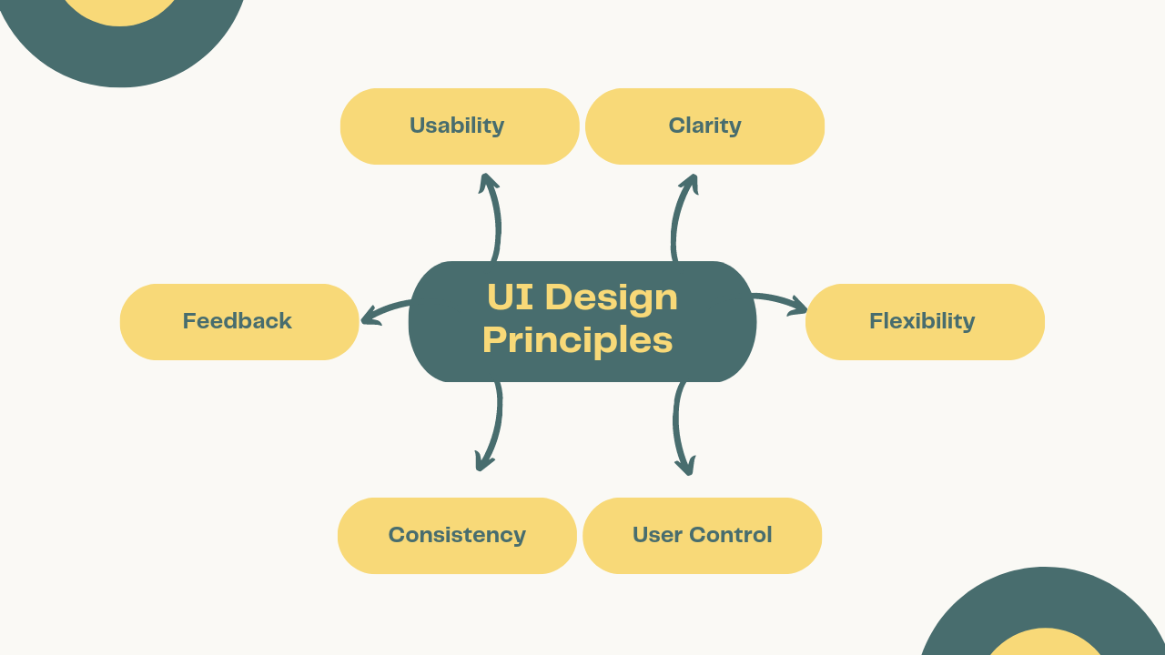

Figure 1 User Interface Principles

### User Experience (UX)

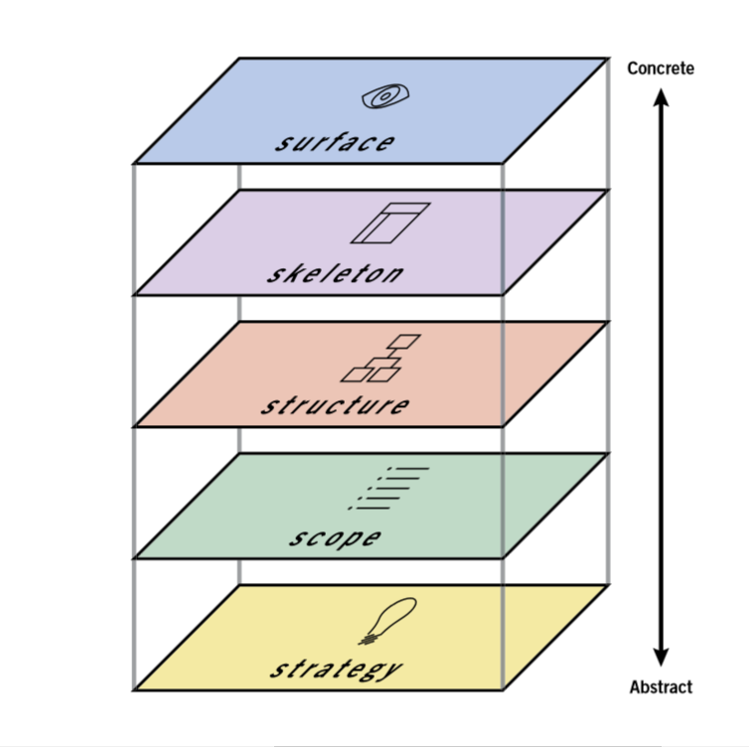

Figure 2 User Experience (UX)

**Strategy**

Identifies the aim of the website or app.  
Defines user requirements and company goals.  
For AgriBaato, the goal is to streamline agricultural transactions while meeting user needs such as real-time pricing and easy market access.

**Scope**

Determines the features and functionalities.  
Provides more information on what the product will and will not function.  
AgriBaato's services include bidding systems, market prices, and product listing.

**Structure**

It focuses on the structure of information and user flow.  
Defines how users can navigate and interact with the contents.  
AgriBaato: Clearly defined routes for farmers and corporations to access their specific features.

**Skeleton**

It deals with the layout, element placement, and wireframes.  
Maintains usability and intuitive design.  
AgriBaato's features include easy navigation, clear action buttons (such as "Post Product"), and price data visualization that is simple to find.

**Surface**

Visual design elements such as colors, typography, and artwork.  
focuses on visuals and branding.  
Regarding AgriBaato: A clean, professional design with agricultural-themed imagery and a welcoming color scheme (for example, green tones represent trust and growth).

### Colour Theory

Color is important for communicating emotion and guiding user behavior.  
Green represents progress and trust, as well as agriculture.  
Neutral tones are used to maintain clarity and balance.  
Contrast is Improves readability, particularly for important features such as market prices.  
The color scheme for AgriBaato will be consistent with agricultural themes while yet being visually appealing.

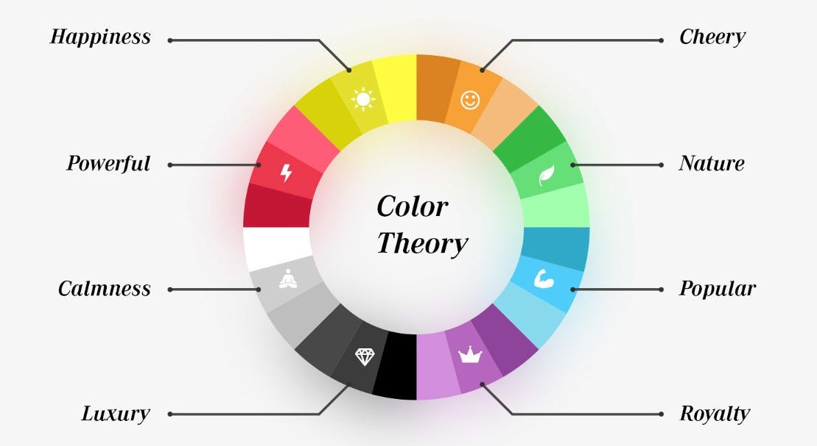

Figure 3 Color Theory

### Typography

Typography improves readability and reflects the brand's tone.  
  
Sans-serif Fonts are modern and clean, perfect for a professional platform.  
Font Hierarchy: Use larger headings for important information (such as market prices) and smaller text for detailed details.  
Line spacing enhances readability, particularly on mobile devices.

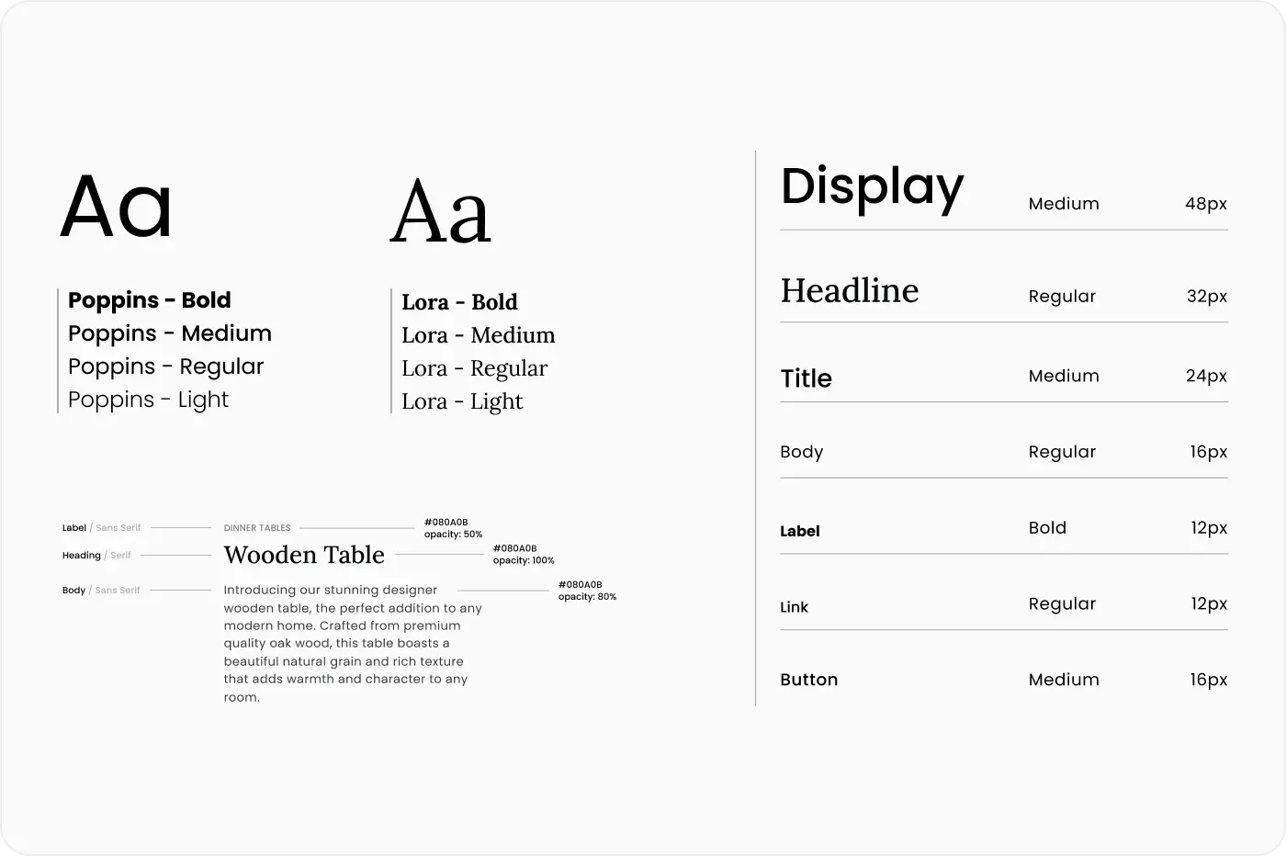

Figure 4 Typography

### Laws of User Experience

(Dubey, n.d.)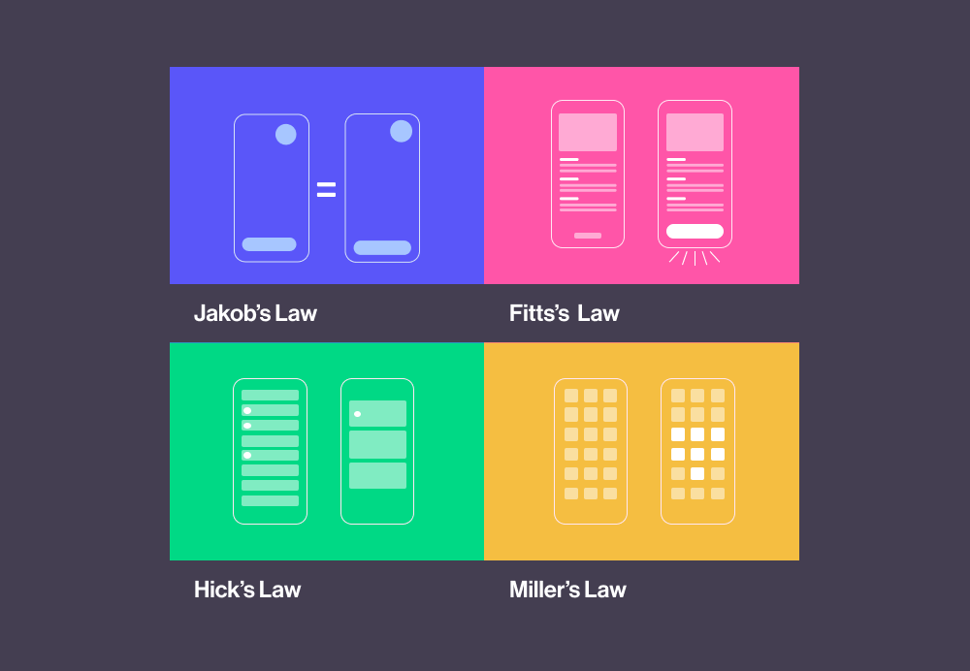

Figure 5 Laws of User Experience

Fitts' Law states that visible, easily clickable buttons should be used for operations such as bidding and posting product listings.

Miller's Law states that information should be broken down into manageable bits, such as dividing features for farmers and companies.

Zeigarnik effect states that to increase involvement, highlight incomplete tasks (e.g., "Complete your profile" reminders)

### Testing Theory

Testing Theory studies ways such as usability testing, surveys, and heuristic review to improve user experiences by discovering and addressing design mistakes early. These methods ensure that designs are user-friendly, efficient, and simple.

## Product Review

### Kisan Network

Kisan Network connects farmers and buyers directly, offering real-time market prices and enabling large transactions (Kisan, 2024).

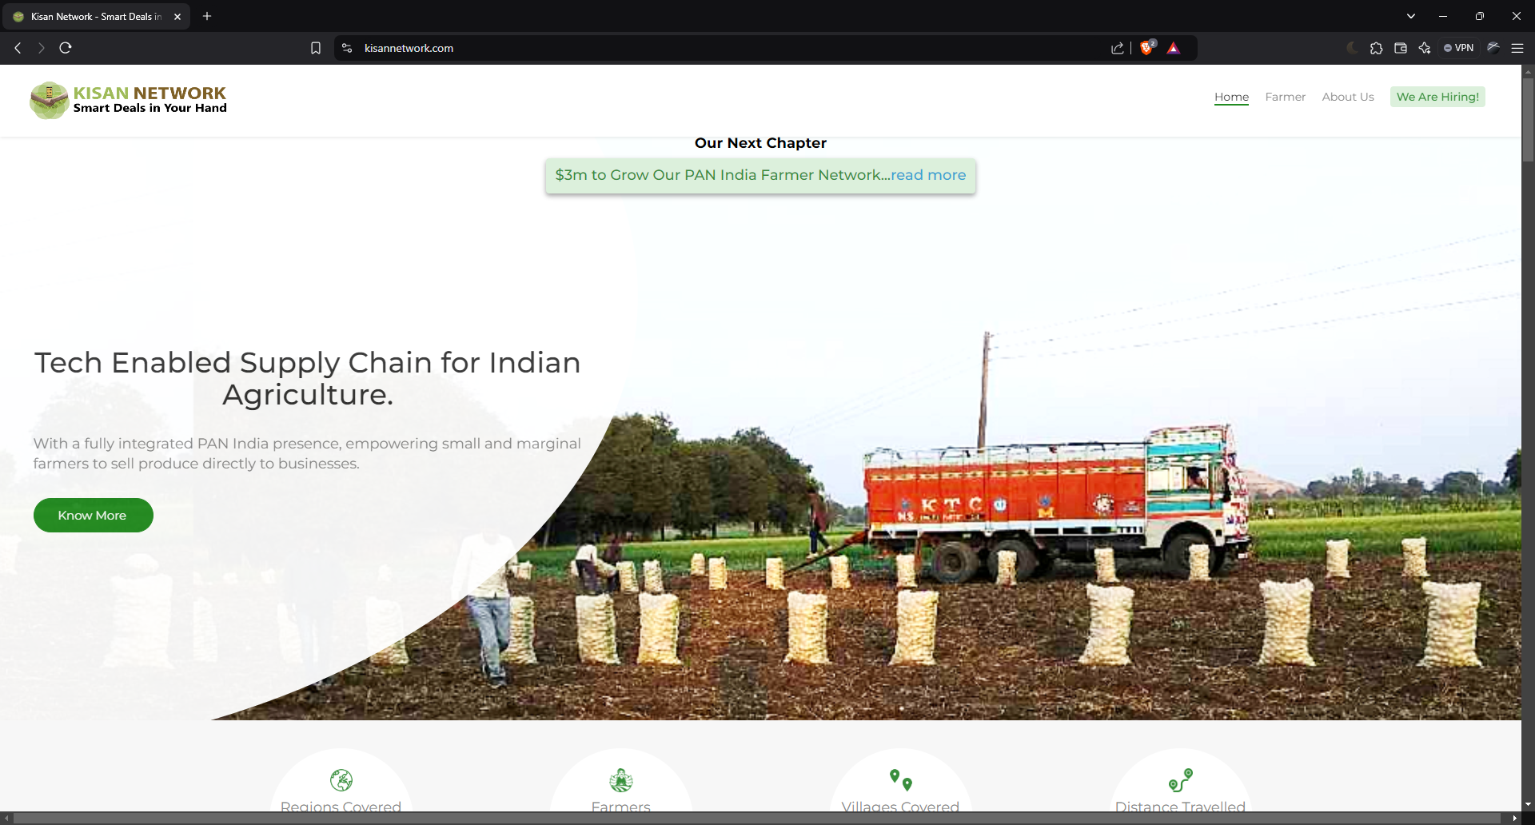

Figure 6 Kisan Network Website

Good Points:  
Real-time market prices: Helps farmers in making informed decisions about when and where to sell their produce.  
Friendly User Interface: Simple and user-friendly layout that responds to consumers of different levels of digital knowledge.

Bad Points:  
Limited Access in Rural Areas: When internet connectivity is weak, the platform's functionality suffers.  
Limited Language Support: The platform is not available in all regional languages, making it unavailable to non-Hindi-speaking farmers.

Analysis

Kisan Network offers farmers a simple yet easy UI, however it lacks a clear navigation arrangement, affecting user experience and easy access.

Implementation

AgriBaato is going to solve these issues by focusing a clear and basic navigation layout that allows for easy access to important details like product listings and market prices.

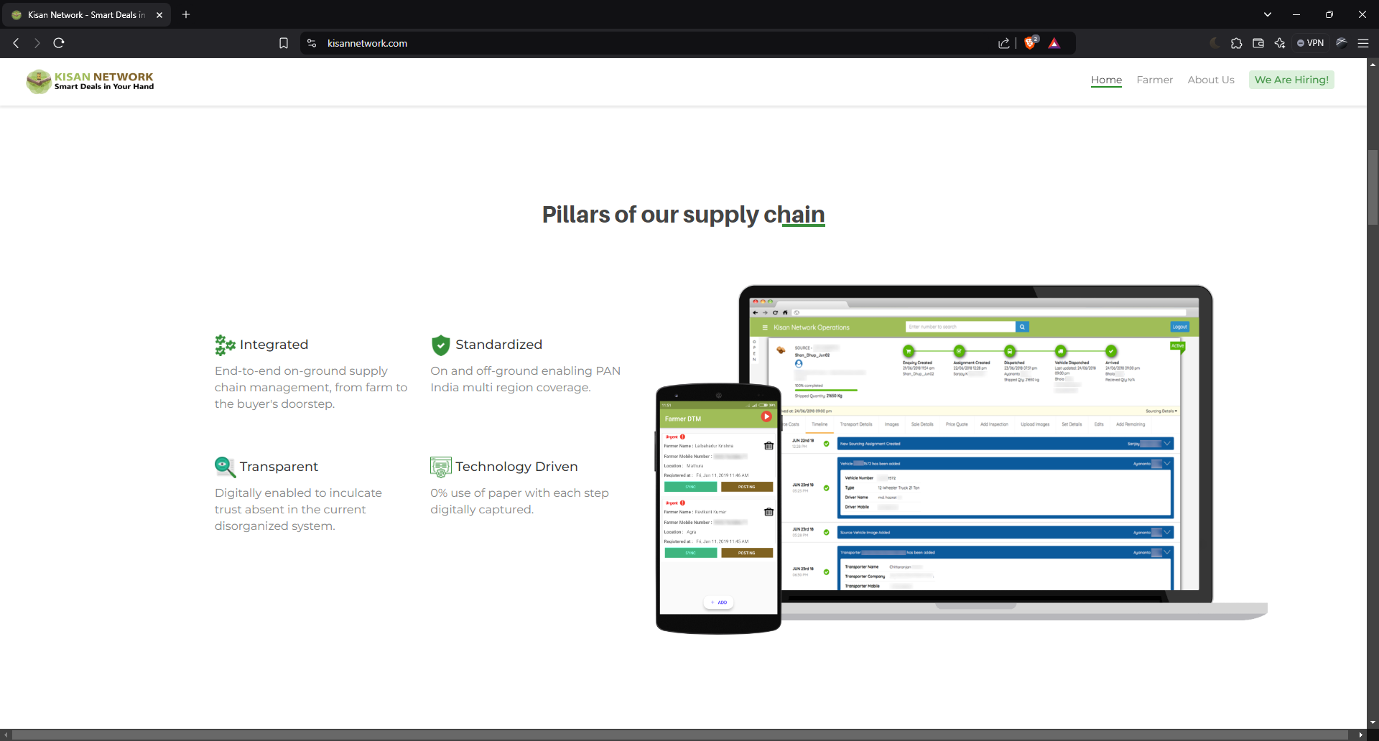

Figure 7 Kisan Network Website 2

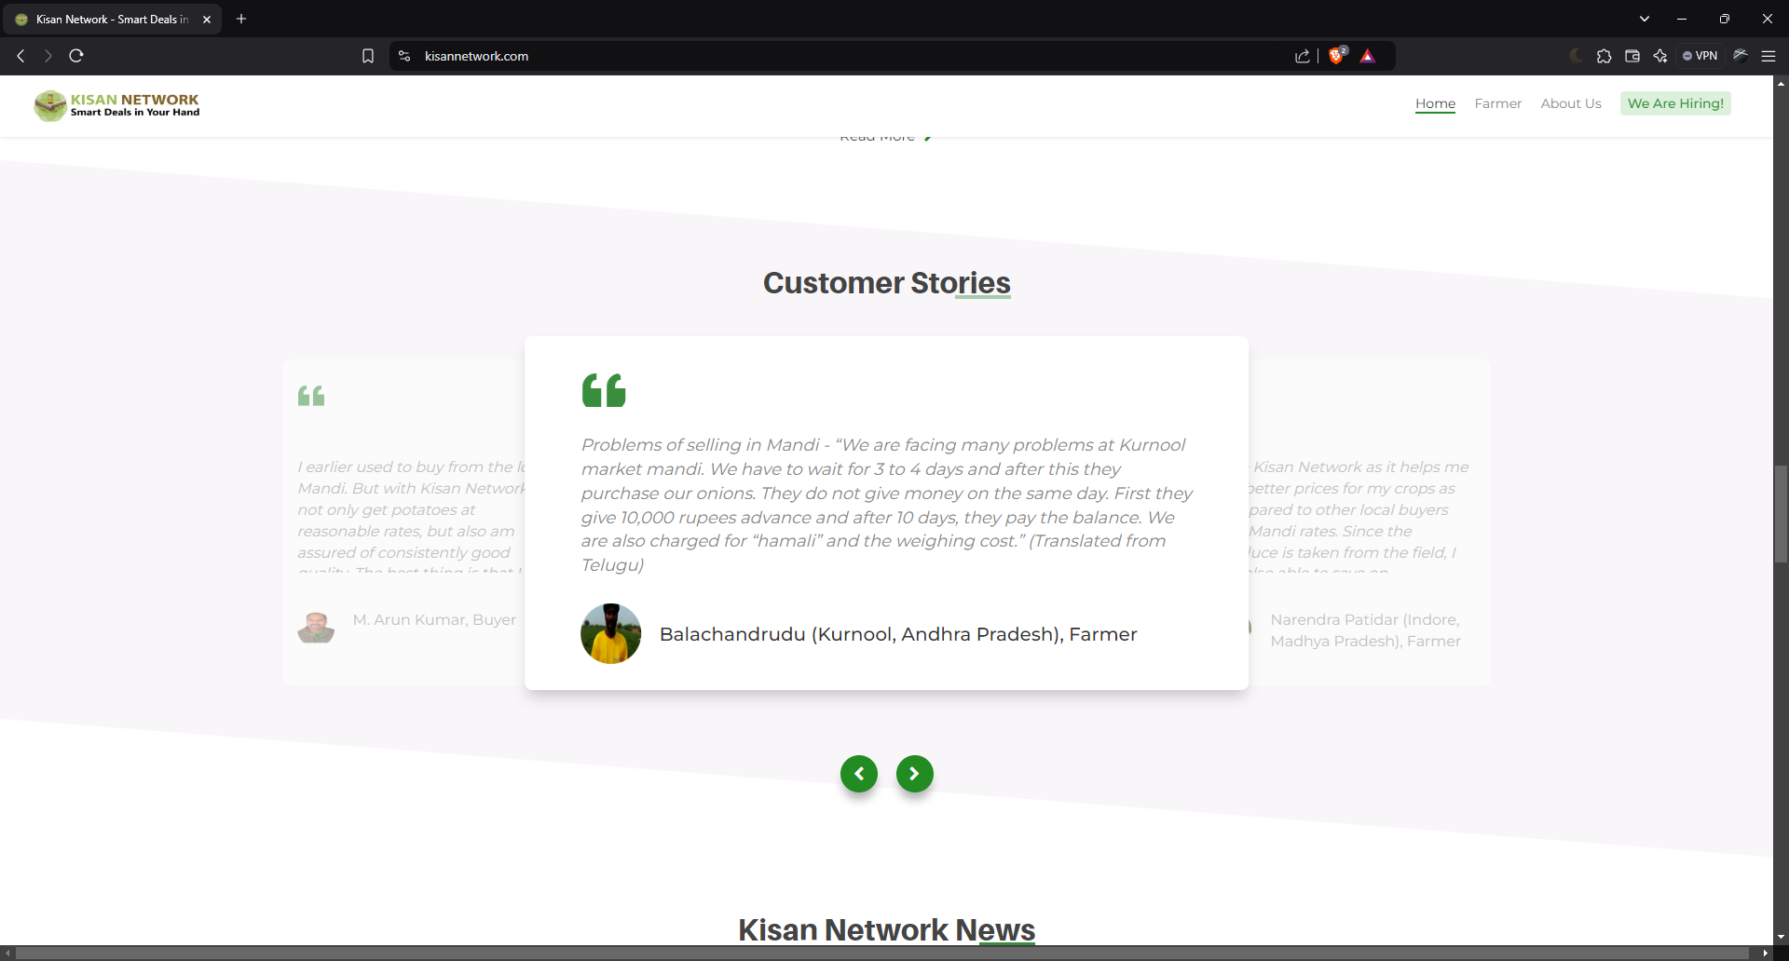

Figure 8 Kisan Network Website 3

### DeHaat

Offers various kinds of services, including consultation, buying, and real-time market prices, with a focus on complete farmer solutions (DeHaat, 2024).

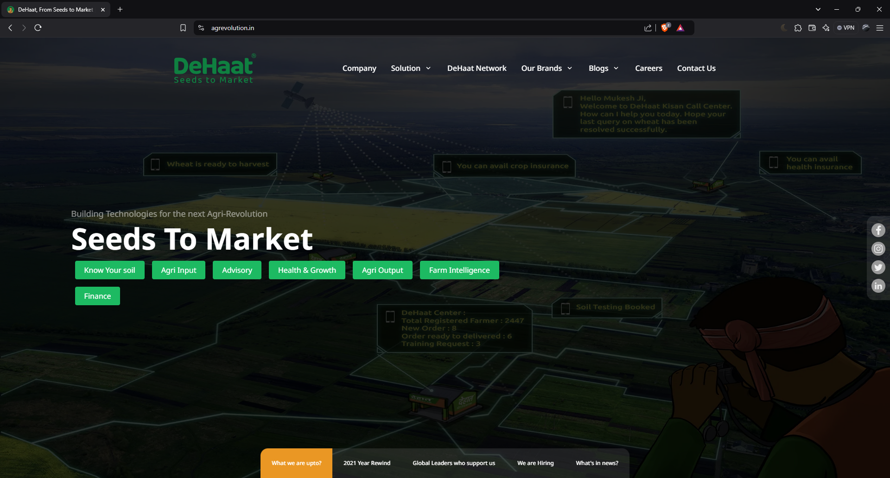

Figure 9 DeHaat Website

Good Points:  
Integrated Services: Provides both market access and farming advice and services.  
Mobile-friendly: Provides a lightweight mobile app for farmers living in remote areas.

Bad Points:  
Users have stated that the interface is crowded, making navigation difficult.  
Limited Attention to Small Farmers: Large-scale farmers profit the most, whereas smaller farmers find the platform less valuable.  
  
Analysis

DeHaat's packed with features a platform, with its level of detail and lack of focus on allowing small-scale farmers, risks losing users.

Implementation

AgriBaato will find a balance between function and ease, with a user-friendly design and abilities such as product highlights and filters to help small farmers stand out.

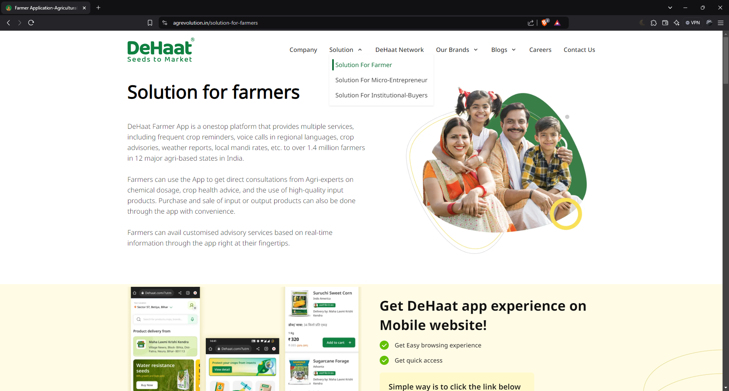

Figure 10 DeHaat Website 2

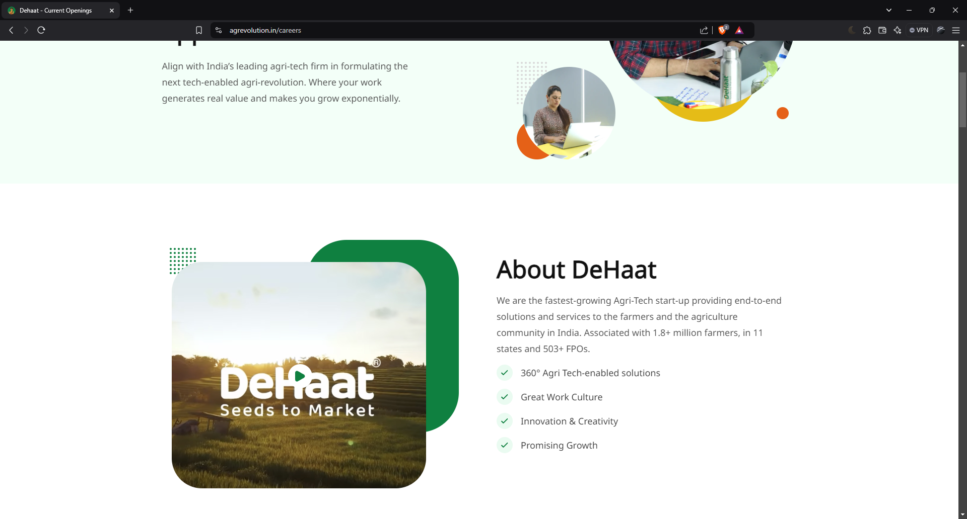

Figure 11 DeHaat Website 3

### Agri Bazaar

A website for Nepali farmers to buy and sell agricultural products, with the goal of improving the agricultural supply chain (Agribazzar, 2024).  
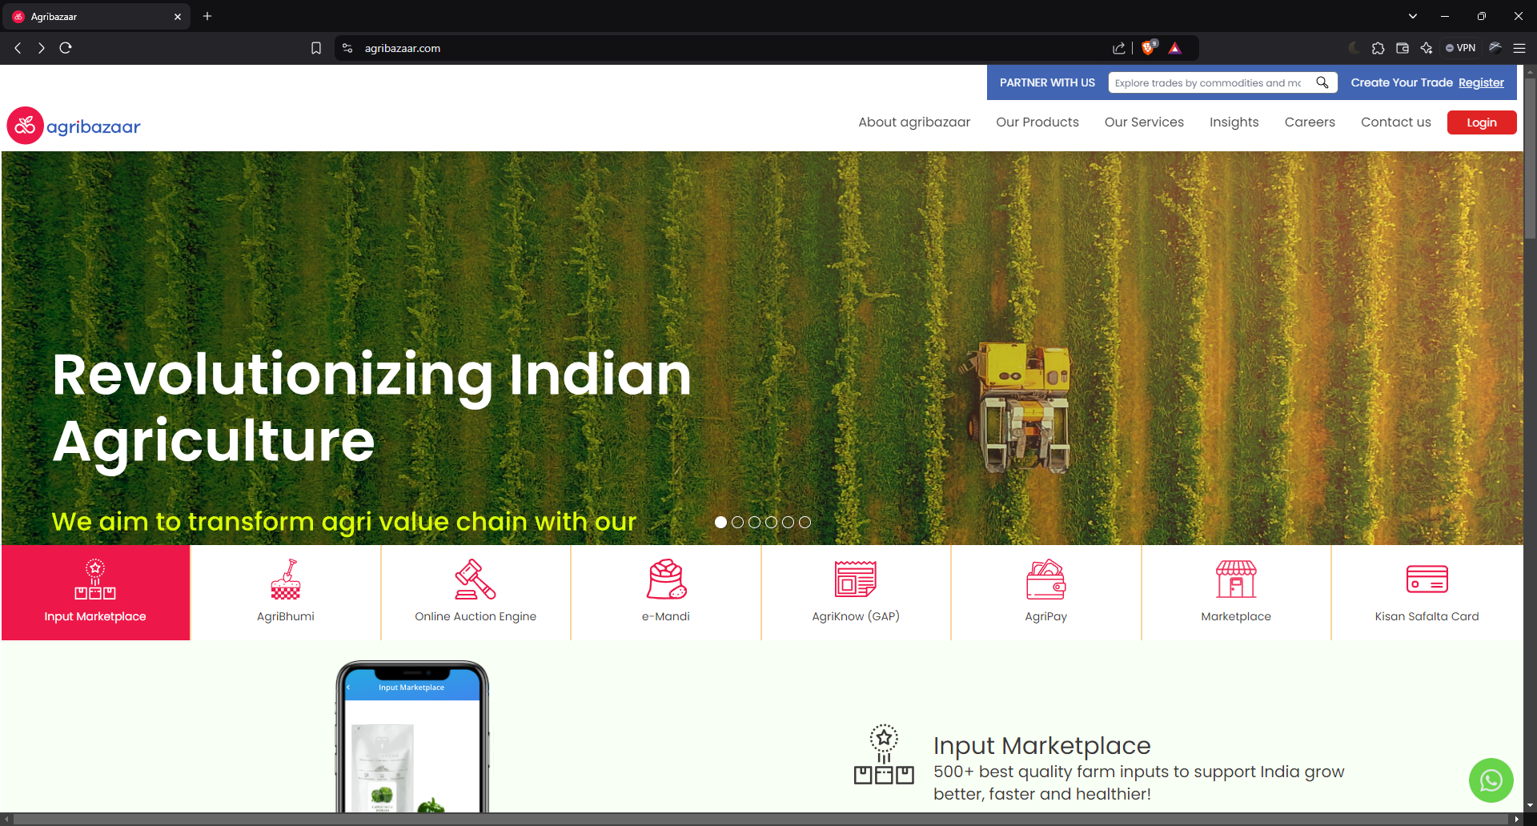

Figure 12 AgriBazzar Website

Good Points:  
Nepalese version: The platform focuses on the needs of Nepali farmers.  
Buyer-seller transactions are simplified with an integrated payment system.

Bad Points:  
Lacks advanced functions such as bidding systems and market analysis tools that can improve user experience.  
Farmers with lower volumes or lesser-known products have a difficult time being noticed on the site.

Analysis

Though AgriBazaar's bidding methods and mobile access are excellent, its demand on reliable connectivity makes it difficult for rural users to use.

Implementation

While keeping mobile responsiveness, AgriBaato will give priority to offline access for essential services like product listings and pricing updates.

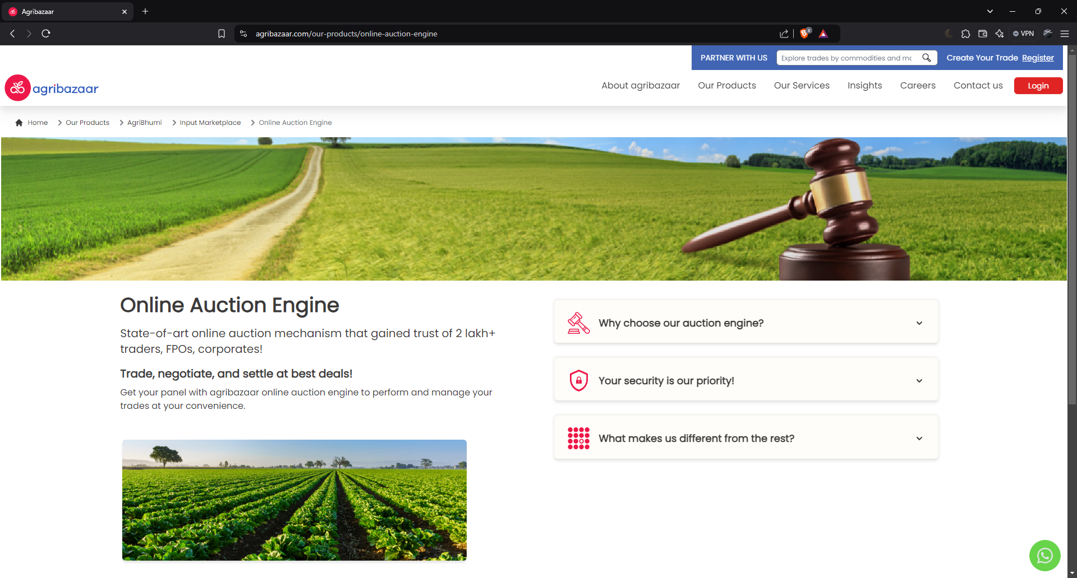

Figure 13 AgriBazzar Website 2

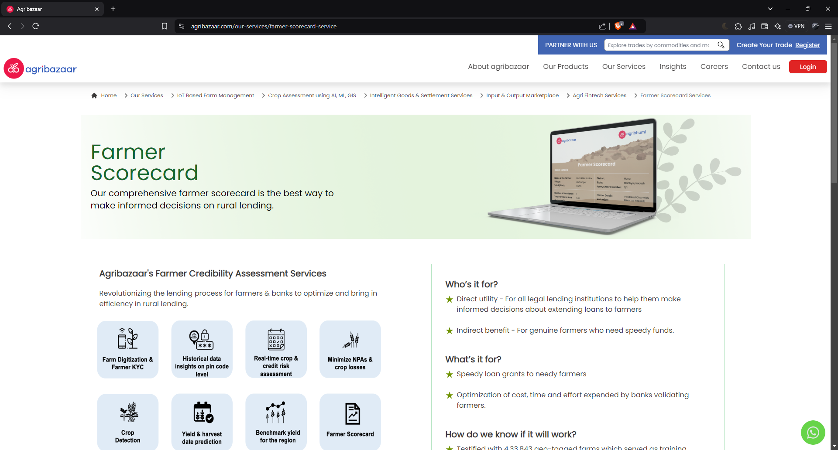

Figure 14 AgriBazzar Website 3

## Summary and Conclusions

The research explored essential theories and principles critical for successful UI/UX design, particularly for platforms like AgriBaato, which aims to improve agricultural transactions in Nepal. Key theories include user interface principles, user experience (UX) principles, colour theory, typography, and the laws of user experience. These concepts guide the design process to create an intuitive and user-friendly platform tailored to meet the specific needs of farmers and agribusinesses.

UI principles like consistency, visual hierarchy, and feedback ensure a seamless, clear, and engaging experience. UX principles, such as usability and accessibility, focus on making the platform easy to navigate. Colour theory and typography influence how users interact with the platform visually, enhancing readability and user engagement. The laws of UX, like Hick’s Law, Fitts’s Law, and Miller’s Law, guide the design in reducing complexity, improving navigation, and optimizing user interaction.

## What to Do in My Project

For AgriBaato's design, I will focus on the following key strategies:

**User-focused Design:** Prioritize simplicity and usability by collecting feedback from clients, teachers, and friends to ensure that the design is easy for both farmers and traders.

**Device Responsiveness:** Create designs for desktop and mobile platforms that allow smooth access across many devices while providing a wide range of user preferences.

**Clear Navigation and Visual Hierarchy:** To increase user engagement, implement simple navigation and visually highlight vital elements such as product listings and bidding systems.

**Focused on customers Features:** To meet the demands of individual clients, customize the design to include advanced capabilities such as real-time price updates and an online marketplace.

Color theory, typography, and minimalist elements can all help to minimize the workload and increase usability for a wide range of users.

## What’s Special About My Project

AgriBaato stands out by offering a complete solution for both farmers and agribusinesses. It features real-time price updates, a bidding system, and a collaborative marketplace, creating a transparent and efficient platform for scaling agricultural businesses.

The design will be tailored to Nepal's agricultural market, ensuring it’s culturally and regionally suitable. With multilingual support and offline access, AgriBaato ensures that all users, even in remote areas, can fully benefit from the platform.

# Section B: Project Proposal

## Project Title

**AgriBaato:** UI Design for Nepal's Agricultural Platform

This project focuses on designing a simple and user-friendly interface for AgriBaato, a platform connecting farmers, traders, and agribusinesses in Nepal. The design will ensure easy navigation, real-time market prices, and multilingual support to improve the user experience for all.



Figure 15 AgriBaato Logo

## Research Question

For AgriBaato, how can I design a user-friendly interface that enhances use and engagement for Nepali farmers and traders?

The aim is to provide a simple, user-friendly design that is perfect for the needs of Nepali farmers and traders. This is how I'll go about it:  
  
User-Centered Design: I'll ask friends and teachers for their opinions. My friends will test the design to make sure it is simple and useful, meeting the demands of farmers and traders, while my teachers will instruct me on design concepts.  
  
Clear and Easy Navigation: Users will be able to easily and clearly access points like market prices, product listings, and bidding systems due to the design's well-organized menus and buttons.  
  
Mobile and Desktop Friendly: The design will function well on both mobile and desktop devices, smoothly adapt to various screen sizes, given that a large number of users rely on mobile phones.

Clear Visuals: Proper use of colors, fonts, and spacing will make important information, such as prices and listings, stand out, making it simple to concentrate on what really matters.  
  
Error and Connectivity Alerts: The design will include options such as displaying saved data in place of real-time updates, along with clear alerts if something isn't working.  
  
Getting Rid of the Middleman: AgriBaato will have features like transparent bidding where suppliers and buyers can communicate directly through chat or message systems. This eliminates rely on middlemen, enabling direct communication and increased profitability between farmers and traders.

## Treatment

Imagine a farmer in a rural Nepali village, opening the AgriBaato app on his smartphone. The interface is simple, with large, clear buttons and vibrant colors that instantly guide him to essential features. He easily navigates to the "Real-Time Market Prices" section, where prices for his crops are updated instantly, displayed in his local language. With just a few taps, he posts his produce for sale, and he receives notifications when traders express interest. As he scrolls, he discovers a bidding system where he can negotiate prices directly with agribusinesses. The layout is clean and intuitive, with every element thoughtfully placed to minimize confusion and maximize ease of use. The app even works offline, allowing him to access vital information, even without a stable internet connection. The experience is seamless, empowering the farmer to make informed decisions, connect with buyers, and grow his business – all through a platform built with his needs in mind.

## Resources

Here’s a detailed breakdown of the resources for your project:

**Software:**

Figma: For UI/UX design, wireframing, prototyping, and collaboration.

Figure 16 Figma

Google Forms: For surveys to gather user feedback and evaluate design preferences.

Figure 17 Google Forms

Windows 11: The operating system for running design software and managing the project workflow.

Figure 18 Windows 11

**Hardware:**

Laptop: Lenovo Legion 5 Pro, offering high performance for design work, prototyping, and multitasking.



Figure 19 Lenovo Legion 5 Pro

Specifications:

Processor- AMD Ryzen 7 6800H with Radeon Graphics 3.20 GHz.



Figure 20 AMD Ryzen 7 6800H with Radeon Graphics 3.20 GHz

RAM- 16.0 GB (15.2 GB usable)

Graphics- NVIDIA GeForce RTX 3060 and AMD Radeon™



Figure 21 NVIDIA GeForce RTX 3060

## Contribution of Others

**Internal & External Supervisor**

Parbat Bhujel (internal supervisor) and Saugat Basnet (external supervisor) will provide direction on UI/UX guidelines and feedback to improve the design. Their insights will help in making sure the project fulfills academic and business standards.

**Friends**

Friends: They will help with usability testing, helping to find areas for improvement, and making sure the interface is simple to use and simple.

**Me**

As the designer, I oversee the AgriBaato website's whole UI/UX design, which includes producing wireframes, prototypes, and final designs for desktop and mobile interfaces. I will make certain that the design is effective, user-friendly, and adapted to the needs of farmers and agribusinesses.

## Evaluation & Testing

**Evaluation**

**Surveys and Questionnaires:** Use Google Forms to collect feedback from users and other people about the design's usability, design, and functionality.

**Analytics tracking:** Create user interaction data to determine the performance of important elements such as navigation and data visibility.

**Post-Launch Evaluation**: Gather information after setup to improve the design based on daily usage and feedback.

**Testing**

**Usability Testing:** Perform regular tests with farmers, traders, and clients to discover problem areas and places for improvement.

**A/B Testing:** Compare different design features to see which version provides the best user experience.

# References

Agribazzar, 2024. *Agribazaar.* [Online]   
Available at: https://www.agribazaar.com/

Anon., n.d. [Online]   
Available at: https://www.linkedin.com/pulse/5-ui-design-principles-sadiq-hussain

DeHaat, 2024. *DeHaat.* [Online]   
Available at: https://agrevolution.in/  
[Accessed 12 2024].

Dubey, S., n.d. *ProProfs.* [Online]   
Available at: https://qualaroo.com/blog/rules-for-ux-beginners/

Hussain, S., n.d. [Online]   
Available at: https://www.linkedin.com/pulse/5-ui-design-principles-sadiq-hussain

Kisan, 2024. *Kisan Network.* [Online]   
Available at: https://kisannetwork.com/  
[Accessed 22 12 2024].

Krug, S., 2014. *Don't make me think, Revisited.* [Online]   
Available at: https://eng317hannah.wordpress.ncsu.edu/files/2020/01/Krug_Steve_Dont_make_me_think_revisited___a_cz-lib.org_.pdf  
[Accessed 2025].

Kumar, V., 2019. *Practical User Research. UX Design Press..* s.l.:s.n.

Mehta, R. S. A. &. P. P., 2020. *Agricultural Platforms: Opportunities and Challenges. Journal of Digital Agriculture.* [Online]   
[Accessed 2025].

nielson, j., 1993. *Usability Engineering.* [Online]   
Available at: https://www.nngroup.com/books/usability-engineering/  
[Accessed 2025].

# Bibliography

Agribazzar, 2024. *Agribazaar.* [Online]   
Available at: https://www.agribazaar.com/

Anon., n.d. [Online]   
Available at: https://www.linkedin.com/pulse/5-ui-design-principles-sadiq-hussain

DeHaat, 2024. *DeHaat.* [Online]   
Available at: https://agrevolution.in/  
[Accessed 12 2024].

Dubey, S., n.d. *ProProfs.* [Online]   
Available at: https://qualaroo.com/blog/rules-for-ux-beginners/

Hussain, S., n.d. [Online]   
Available at: https://www.linkedin.com/pulse/5-ui-design-principles-sadiq-hussain

Kisan, 2024. *Kisan Network.* [Online]   
Available at: https://kisannetwork.com/  
[Accessed 22 12 2024].

Krug, S., 2014. *Don't make me think, Revisited.* [Online]   
Available at: https://eng317hannah.wordpress.ncsu.edu/files/2020/01/Krug_Steve_Dont_make_me_think_revisited___a_cz-lib.org_.pdf  
[Accessed 2025].

Kumar, V., 2019. *Practical User Research. UX Design Press..* s.l.:s.n.

Mehta, R. S. A. &. P. P., 2020. *Agricultural Platforms: Opportunities and Challenges. Journal of Digital Agriculture.* [Online]   
[Accessed 2025].

nielson, j., 1993. *Usability Engineering.* [Online]   
Available at: https://www.nngroup.com/books/usability-engineering/  
[Accessed 2025].

# Appendix

## Gantt Chart

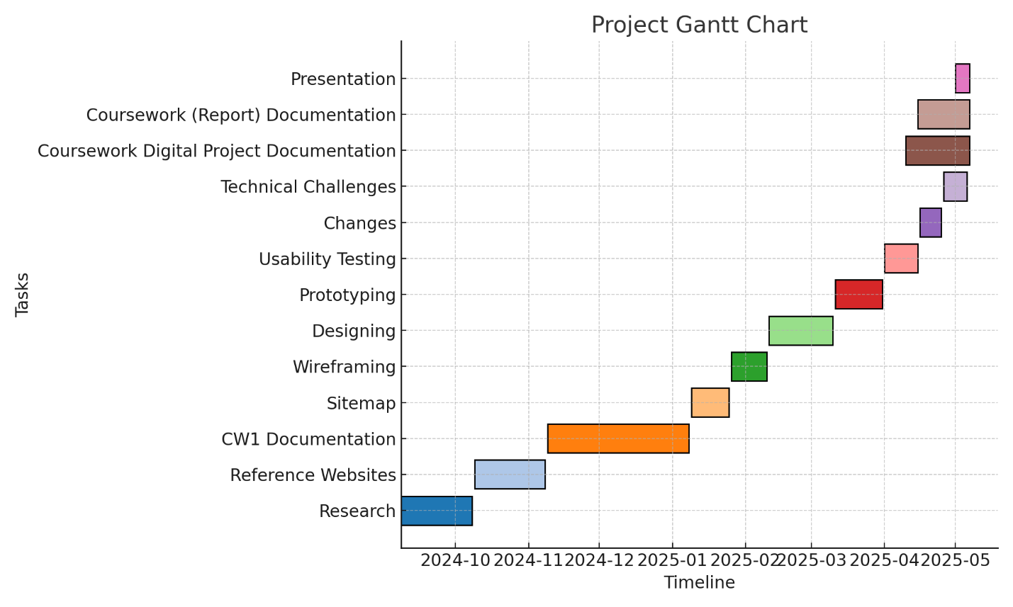

Figure 22 Gantt Chart

## Log Sheet

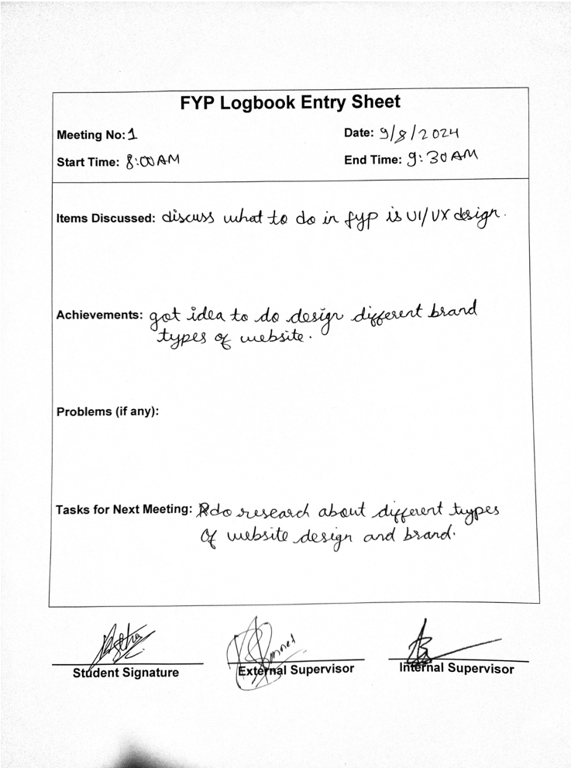

Figure 23 Log Sheet 1

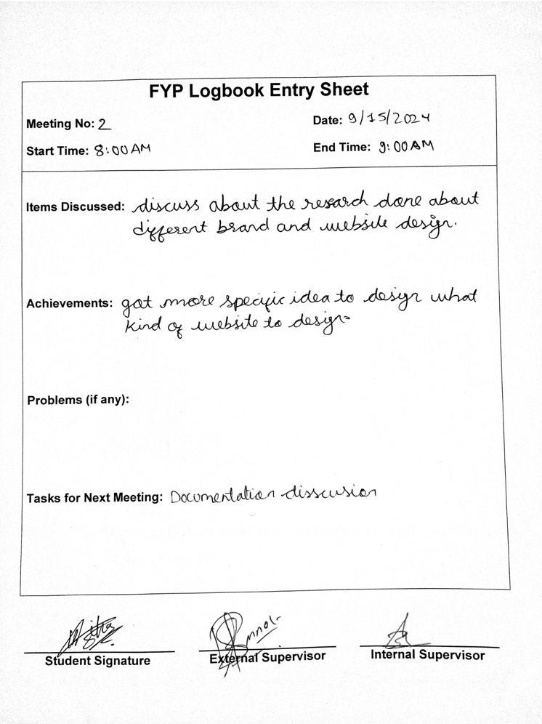

Figure 24 Log Sheet 2

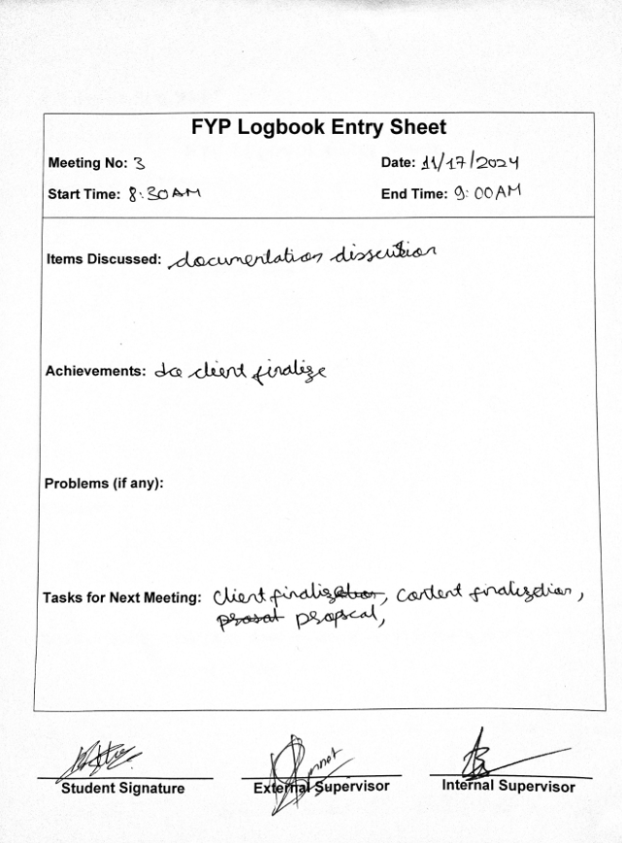

Figure 25 Log Sheet 3

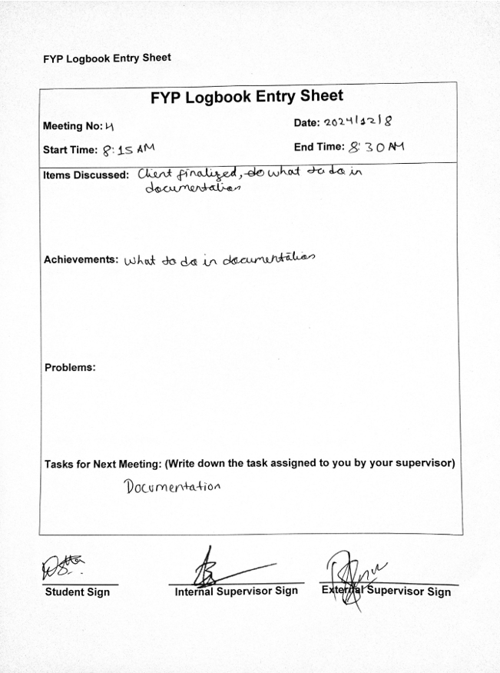

Figure 26 Log Sheet 4

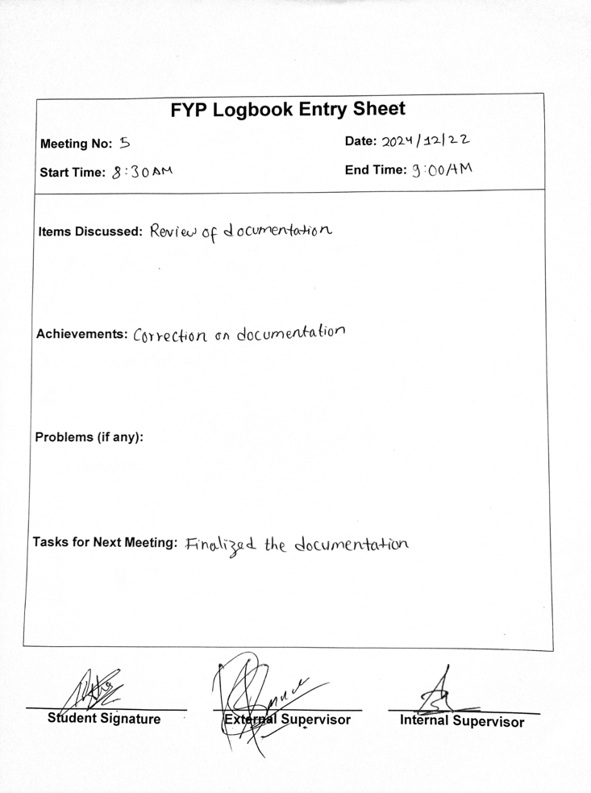

Figure 27 Log Sheet 5

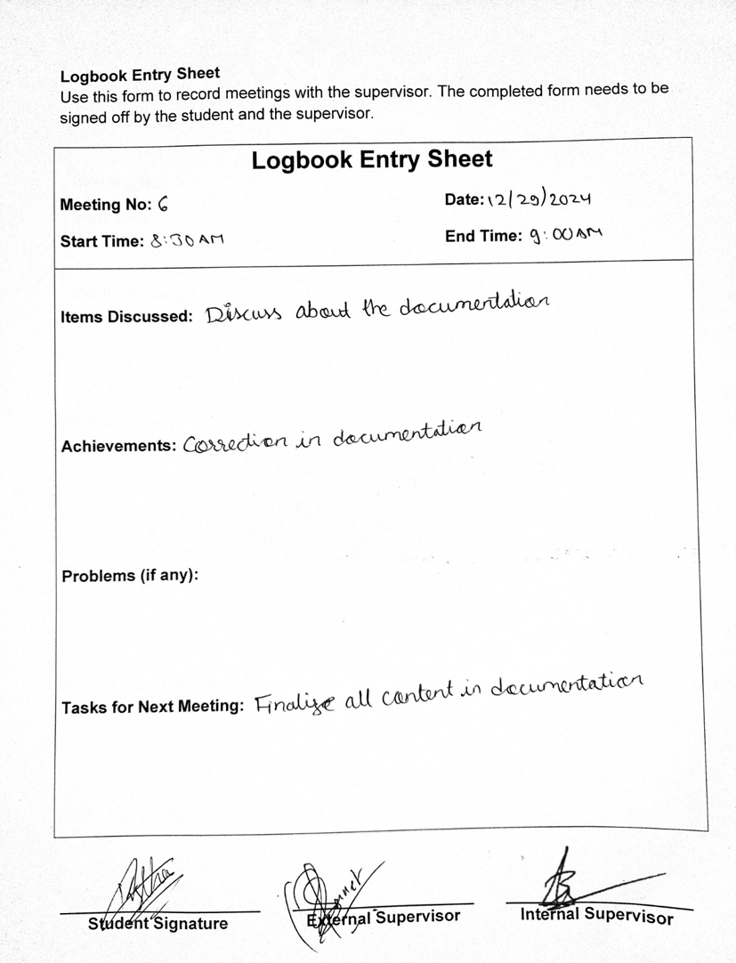

Figure 28 Log Sheet 6

## Similarity Check

